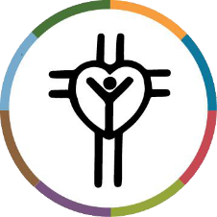

Inter Parish Ministry
Alida Hart, President and CEO

The Road That Leads To Life

As the saying goes, “Life is a journey, not a destination.” The journey we all went through during the Covid-19 pandemic has at times felt like an expedition with no clear GPS or road map. Matthew 7:14 states, in part, that the gate is narrow and the road is hard that leads to life. For many of us, it has been a hard and heartbreaking year and a half. Perhaps you lost a loved one, saw your income plummet, felt alone and isolated.
At IPM Food Pantry, we saw first-hand the surge in food insecurity. We saw lines of cars 30 – 40 deep of clients waiting patiently for food, heard stories from families that were struggling to put food on the table and shed tears with clients that were frightened and alone due to Covid.
Personally, it broke my heart. But I knew - we all knew - we had to keep moving and serving. We soon found the narrow gate referenced by Matthew opened up and the route became clearer once we “hit the road.” In order to serve better, IPM had to increase food access points in more remote corners of our service area to meet families where they live, learn, play and pray.
Showing up at schools, church parking lots and affordable housing complexes, IPM is serving more families than ever before with our mobile and pop-up food pantries. IPM has also become a Community Food Hub for over 30 agencies and schools. Distributing food throughout the community by coordinating pickups and deliveries to reach even more families. For example, we provide emergency food boxes and fresh produce to the VA, who in turn delivers it to homebound and homeless veterans.

As one client told us, “This year was absolutely frightening. IPM kept me alive.” We thank you for helping us help others. IPM is blessed to call Lutheran Church of the Resurrection our friend.

The journey for us is now inspiring and heartwarming. Our new road to serve leads to life and hope.

